Operations Module
A Quick Guide

1. Consumption Reports

These reports will display the data related to the Consumption of bunkers,Average speed of vessels and Port Calls .To Navigate to this module login into BI instance using the below url.
http://192.168.166.203:9704/analytics/saw.dll?bieehome&startPage=1

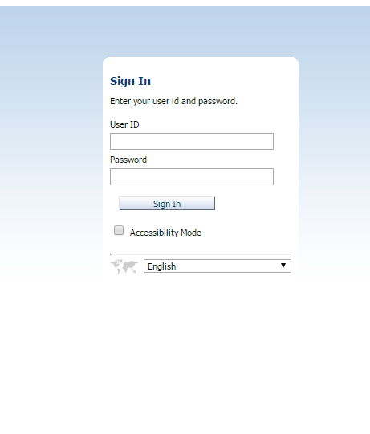

Enter the below Credentials
User ID : Operations
Password : welcome1

Once Logged in then navigate to the dashboards and select Dashboard
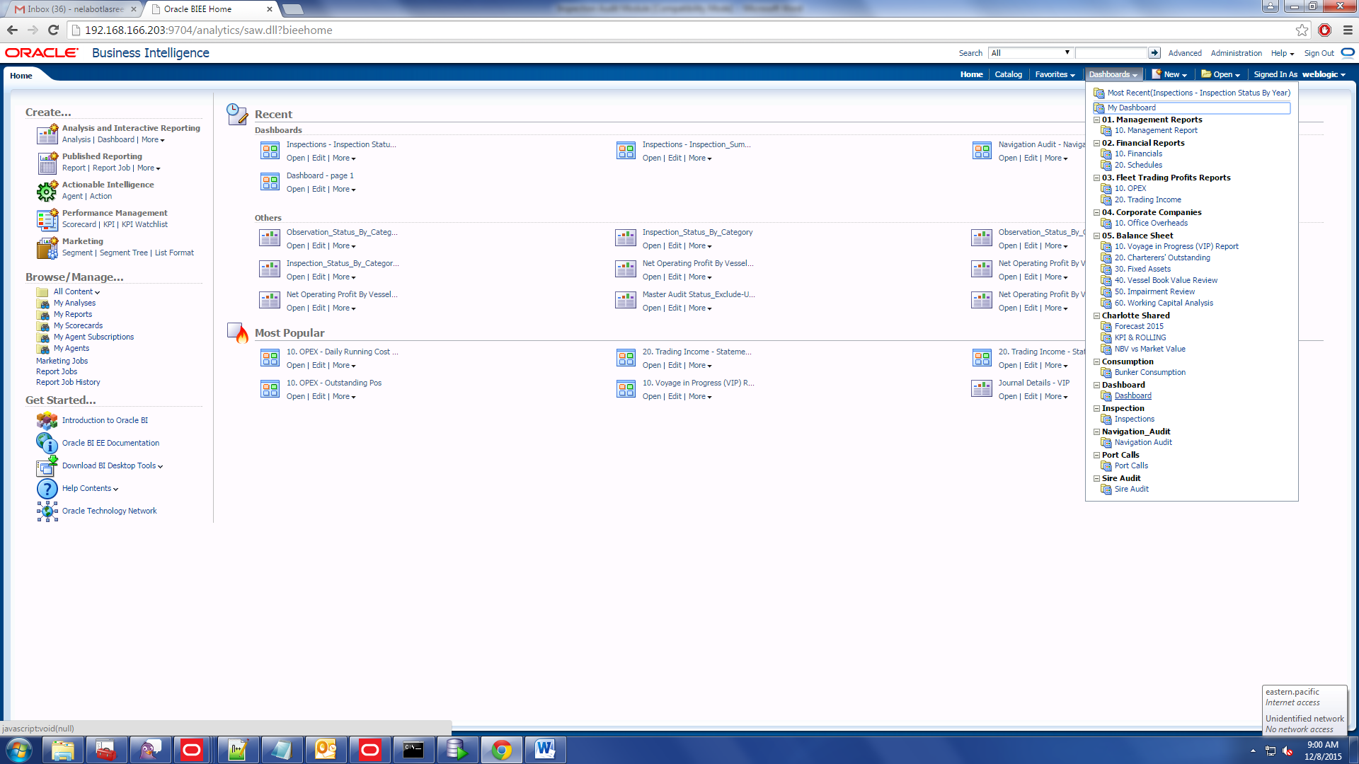

- Once logged in then click on the URL to navigate to the required report.
    - There are few Parameters for the each report. They are
        - Year : Select the particular year for which the data to be displayed.
        - Fleet : Select the Fleet type required.
        - Ownership :Select either EPS-SG or EPS-UK to extract information related to vessels owned by either EPS-SG or EPS-UK
As shown below:

